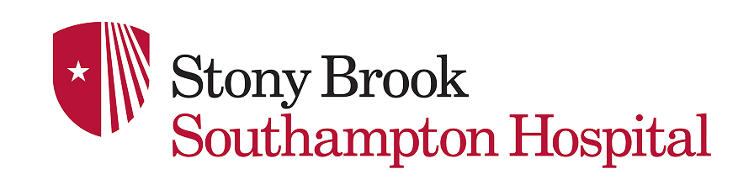
-FAMILY SUPPORT WORKSHOP-
6 WEEK SERIES
FREE OF CHARGE & OPEN TO THE COMMUNITY
Beginning Friday, October 25, 2019, November 1, 2019,
November 8, 2019, November 15, 2019,
November 22, 2019, and November 29, 2019
5:00pm-6:00pm
AVAILABLE AT THE WORKSHOP
DEFINING ADDICTION
UNDERSTANDING CODEPENDENCY
WHAT RECOVERY LOOKS LIKE
PEER SUPPORT FOR FAMILIES
SUPPORT GROUPS FOR FAMILIES/NARCAN TRAINING
PUTTING IT ALL TOGETHER: NAVIGATING TREATMENT

For more information contact: Christine Cantrell, BA, CASAC 2
PH: 631-655-6839 EMAIL: Christine.Cantrell@stonybrookmedicine.edu
Location: Stony Brook Southampton Hospital, Parrish Hall, 240 Meeting House Lane, Southampton, NY 11968
Next to Emergency Department off Herrick Rd.

